STUDENT BEHAVIOUR, SUSPENSION AND PERMANENT EXCLUSION POLICY

OVERVIEW

For a student to be successful in any school or organisation it is vital that their behaviour conforms to the expectations of that organisation. We also want all our students to be good citizens within society. It is this philosophy that lies at the heart of Marshfields behaviour management.

If we are to achieve the above aims, we believe that everyone in our community (including parents) must be encouraged to work together positively to achieve them. We are committed to developing a positive climate which places learning as the number one priority and realises that we need to teach good behaviour. We believe that a strong ethos of achievement and good behaviour comes from us all working together within a clear framework. Every member of staff has a responsibility to uphold the procedures outlined in this policy. To change the behaviour of each young person it is vital that we do two things:

1. Address poor behaviour firmly and consistently
2. Notice, acknowledge and reward good behaviour

Reflection and restorative approaches are used to facilitate change. Interventions are highly personalised, and we are able as a school to draw on appropriate therapeutic support swiftly and effectively. As a result, our students are empowered to take ownership of their behaviour and are then able to re-engage with their learning at Marshfields.

RATIONALE

Our primary goal is to reengage our students with their education and where possible reintegrate students back into mainstream provision. We do this with the following in mind:

- Behaviour is not the child.
- Behaviour has a purpose and communicates unmet needs.
- Behaviour has consequences. Consequences are life lessons.
- Relationships are key to encouraging reflection. Reflection facilitates change.
- Internal control leads to long term change.

We believe that:

Children and young people want to behave well.

- We believe that our students are happy when they behave well and when that behaviour is recognised and acknowledged by adults and their peers. Students can behave well when their needs are well met in school, at home and in the community.
- Linking good behaviour to a student’s identity builds self-esteem.
- Actively build trust and rapport
- Positive relationships are the heart of all we do. By building rapport with students requires effort, commitment, and skill. It happens in many simple ways: learning names, greeting students in corridors, showing interest in what they do – both in the classroom and out of it, show interest in them as human beings. To influence and guide students it is necessary to enter their world and be aware of their perspective.
- Students achieve more when they are confident and trusting. Having confidence and trust encourages risk-taking which leads to learning.

Although we believe that the key to good behaviour in schools is positive engagement with learning, there are times, for some students, when additional help is needed to keep them fully engaged.

External discipline may suppress anti-social behaviour, but long-term behavioural change comes from developing internal discipline. We manage the development of internal discipline to gradually replace external discipline. e.g., we consider the whole child or key areas of their life, and work towards them having control over these rather than those controlled by staff.

We believe in the following Rights.

- The right to learn.
- The right to teach.
- The right to feel safe (physically and emotionally)
- The right to respect and dignity.

Having rights allows the teacher to move beyond the “Because I said so” approach.

We believe in the following Responsibilities.

Students must be responsible for their own behaviour. Using the language of choice is a powerful way of doing that. As they realise, they are making choices in many areas of life the teacher can guide them to more socially appropriate choices. Good choices should be rewarded, poor choices always have consequences. “You enjoy the right to feel safe therefore you must take responsibility so that others can feel safe.”

Our Mission Statement is:

We ensure Marshfields School meets the complex needs of these students. We offer a rich curriculum which develops students and prepares them for the world of work, balanced against a wide range of extra-curricular trips, visits and opportunities to encourage a love of learning. Our students have excellent attendance and enjoy coming to school.

Our Behaviour Values are:

HIVE

Helpful
Inspiring
Values
Empowering

These values underpin all the experiences for both adults and children during their time at Marshfields.

Policy Objectives:

- To provide guidance for staff, parents, governors, and other stakeholders on how we keep children and young people safe.
- To provide an inclusive model for our understanding of behavioural needs
- To underpin our beliefs with evidence-based practice and current research

Our Behaviour strategy is aimed at improving educational outcomes for all students by promoting and supporting their engagement with education.

Student behaviour, both pro social and anti-social, should be managed with sensitivity and professionalism consistent with Cambridgeshire Steps.

Staff need to constantly re-examine their responses, attitudes, and behaviours to appreciate the messages that they are giving Students. They will be familiar with clear guidelines and strategies, through knowledge of the principles of Cambridgeshire Steps to help maintain positive behaviour and discourage and understand ‘anti–social’ behaviour when it occurs.
All Staff should focus on de-escalation and preventative strategies rather than focusing solely on reactive strategies.
BEHAVIOUR DESCRIPTORS:

Difficult Behaviour

- Using inappropriate language
- Inappropriately dressed.
- Refusing to hand in prohibited items
- Name calling
- Putting self in danger
- Refusal to engage in the lesson.
- Smoking within school boundaries
- Leaving class without permission
- Verbal Bullying
- Disruption to the learning of others
- Deliberately lying/avoiding the truth
- Swearing directly to cause offense.
- Persistent refusal to follow Instructions Truanting lesson / Persistent lateness /leaving lessons without permission.
- Possession of contraband
- Verbal abuse

Dangerous Behaviour

- Fighting
- Assault to pupils or staff
- Physical with staff (personal space, pushing) Damage/ destruction of school property.
- Activating Fire alarm or Extinguisher
- Endangering a fellow pupil/Staff member
- Truancy (possible safeguarding issue)
- Truanting lesson / Persistent lateness/ leaving lesson without permission (possible safeguarding issue).
- Climbing on the roof or in and out of windows
- Failing to follow Health & Safety guidelines.
- Possession of an offensive weapon
- Theft
- Possession of contraband, Class A, B, or C drugs; alcohol or legal highs abuse
- Persistent refusal to follow AHT, DHT or HT instructions.
- Bullying pupils/staff physically
- Intimidating behaviour
- Sexual harassment or violence
- Bullying pupils/staff physically
- Intimidating behaviour
- Sexual harassment or violence

Dangerous behaviour: Breaches of health and safety rules or behaviour which endangers any of our community will be dealt with on an individual basis as and when they occur. All staff receive Step On training from our team of trainers and are skilled at de-escalation and behaviour management. If the need arises and an individual's risk management plan deems it necessary, the relevant staff will receive Step Up training. As allowed under Section 93 of the Education and Inspections Act 2006 staff may use reasonable force to prevent students from hurting themselves or others, from damaging property, or from causing disorder.

KEY BELIEFS

At Marshfields we believe that:

- Students want to behave well.
- Behaviour is a means of communication – we must ensure that all students are supported to communicate their needs safely and pro-socially.
- With the right support and intervention, children and young people can learn to improve their behaviour and manage well.
- Mistakes are part of the learning process, and we recognize that all our children and young people are at different stages of the developmental process.
- All adults can learn strategies to support young people to improve their behaviour.

We adults can support the children and young people in our school by:

- The quality of our relationships with each other and them
- The quality of our provision
- A well-informed understanding of their needs
- The scaffolding we put in place.
- Observation, evidence gathering and analysis – so that our interventions are well informed and planned.
- Working in close partnership with parents and carers
- Investing time to allow children to practise and make mistakes.

The scaffolding consists of:

- Accessible modes of communication
- Clear and realistic expectations
- Boundaries
- Routines
- Rewards and consequences
- Reparation wherever possible and appropriate
- Descriptive praise
- Fair and predictable responses to both prosocial and anti-social behaviour

MENTAL HEALTH AND WELL BEING

DfE guidance: ‘Mental health and behaviour in schools - November 2018. This advice clarifies the responsibilities of the school, outlines what they can do and how to support a student or young person whose behaviour – whether withdrawn, anxious, depressed or otherwise.
– may be related to unmet mental health needs.

Risk factors relevant to mental health can relate to the student themselves, their family, and the community or life events. Risk factors are cumulative, children exposed to multiple risks such as social disadvantage, family adversity and cognitive or attention problems are much more likely to develop behaviour problems.

Conscious and subconscious behaviours
Behaviours should be analysed using the questioning below to explore the two types of behaviours and ensure that we do not assume based on a preconceived idea that all behaviour is choice.

Subconscious behaviour (behaviours that choose us)
Behaviours that are evident without any thought or planning. Consider:
- Is there a medical or habitual cause?
- Is there an emotional overwhelming cause?

- If so, what is causing the anxiety, fear, confusion, anger, embarrassment etc.?
- How can we protect the child from the overwhelming experience or feelings?

Staff will find it useful to think of other real examples of subconscious behaviour e.g., outbursts of anger, freezing on the spot, uncontrolled swearing, crying, pen clicking etc.

Conscious behaviour (behaviours that we choose)
Behaviours that are the result of thought or planning. Consider:
- How does the behaviour serve the student?
- What is the motivation to behave anti socially?
- What is the motivation to behave pro socially?

- What are the expected limits to their freedom?
- How can I impact on the child’s beliefs or values?
- What does the child need to learn?
- How am I going to teach them?

How do we teach behaviour?

All staff aim to TEACH behaviour by using the following strategies:

- Build positive and purposeful RELATIONSHIPS.
- Be a ROLE MODEL for students by demonstrating positive pro social behaviours.
- Develop a CONSISTENT approach when working with students.
- Use SCRIPTS and ROUTINES to de-escalate possible anti-social behaviours.
- Child’s name
- I can see something has happened.
- I am here to help.
- Talk and I will listen.
- Come with me and…………

- Use POSITIVE PHRASING to encourage Pro Social behaviour. Staff will have an

understanding of the link between conduct disorders and mental health and well-being and will not use terms such as “a student is kicking off” or “going into one.”

- PLAN effectively for each students’ unique needs and individualise where appropriate.
- Manage REWARD and POSITIVE reinforcement to create Pro Social Positive Experiences

- Provide COMFORT and FORGIVENESS to students in crisis.

Escalation

Planned responses to escalating behaviour can include:

POSITIVE PHRASING e.g., “Stand next to me” “Put the pen on the desk,” “Walk with me.”

- LIMITED CHOICE e.g., “Put the pen in the box or on the table,” “Talk to me here or in the office.”
- DISEMPOWERING THE BEHAVIOUR e.g., “Come and find me when you return,” “You can listen to me from there.”
- NATURAL CONSEQUENCES logically connected to the behaviour.

Planning Documents to support Inclusion:

1. Roots and Fruits

These are used to identify the causes of student behaviour and to communicate the solutions to it.
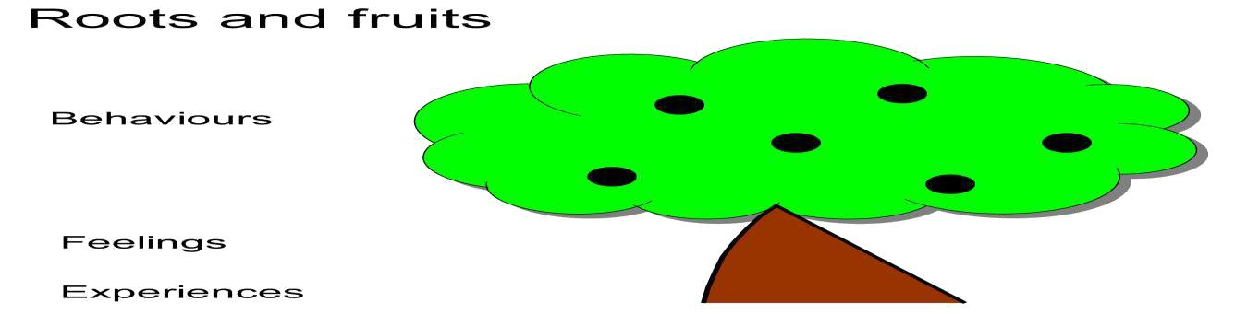

2. Anxiety Mapping

Staff will use ANXIETY MAPPING for students to identify factors that may cause higher levels of anxiety and thereby trigger difficult or dangerous behaviour. This will allow staff to plan differentiation and interventions that can be used to reduce anxiety and risk.

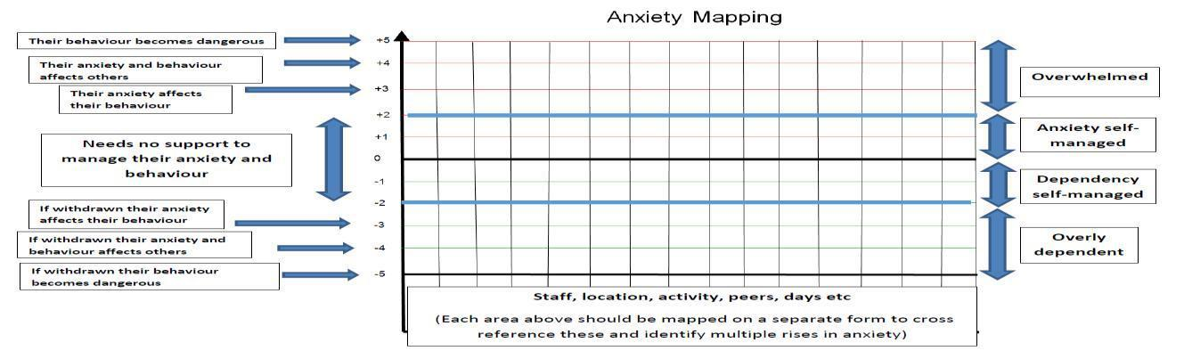

- Risk Reduction Plans

Typically, this will be used where students who may at times need some specific form of intervention to maintain their own safety and that of others and to ensure learning takes place for all.

A plan will:
- Involve parents/carers and students to ensure they are clear about what specific action the school may take, when and why.
- Include a risk assessment to ensure staff and others act, consider the risks, and learn from what happens.
- Consider the age, understanding, and competence of the individual students.
- Consider approaches appropriate to each student’s circumstance and will focus on the 3 stages in progression.
- De-escalation, managing harm and Reflect - Repair – Restore. (Anxiety Mapping –Cambs STEPS)

Some children need specific and detailed planning, which could include a shortened day, off-site education, or home-based learning. When significant adaptations are made to a student’s learning day, we always plan jointly with the parents and carers and the Multi Agency Support Team, the Local Education Authority, and external agencies. Information on SIMs is key to this.

Debrief (Reflect, Repair, Restore)

Staff and Students will have the opportunity to revisit situations and where necessary and appropriate to help ‘repair’ any of the damage done through any episode of difficult or dangerous behaviour considering the age, understanding, and competence of the individual student. Any consequences of the behaviour should have social validity and have natural consequentiality so that the student can be helped to understand the link between behaviour and its consequences.

Staff to follow the reflection flow chart (see appendices) to help students reflect upon their behaviour and the feelings it produced in all involved. Students then consider how they could do things differently and more positively next time – this encourages a growth-mind-set approach.

The flow chart also has a restorative aspect by enabling students to consider any repairs (to relationships or property) that need to be carried out. Debriefs can be facilitated by any adult in centre as sometimes it is helpful for them to be impartial.

If further consequences are needed, we aim to make them reasonable, proportionate, and educational and discuss them with the students.

Examples of consequences are:

- Using a bike inappropriately onsite = Unable to bring bike to centre for a set period
- Damaging walls = Work with the site manager to fix the damage
- Misuse/breaking equipment or furniture = Receive a bill and work out a payment plan
- Refusing to behave appropriately while being transported in vehicles = Miss next offsite activity/ Travel separately to rest of group
- Misuse of equipment in cookery = Theory lesson in place of a practical one

Sometimes the protective educational consequence of dangerous behaviour will be a fixed term exclusion. This could be to allow time for the incident to be investigated, further education for the individual to be made safe or where criminal activity has taken place.

As above, any learning time that has been missed needs to be made up in the student’s own time. Sometimes this means that leaving for home may be delayed.

Wherever possible debriefs and missed learning time should be conducted on the same day. While most behaviour issues can and should be dealt with by the class teacher in the first instance, persistent or more serious behaviour will need to be passed on to the Pastoral Team, AHT or DHT.

Where a student may be delayed in leaving from home and/or being placed in inclusion parents will be contacted in advance to advise them of this so they can help prepare their son/daughter for this consequence.

Learning time

EXPECTATIONS

We model and build relationships based on trust and respect; therefore, interactions within centre are expected to be calm, respectful, and safe. When students are struggling to maintain this, they are reminded of the expectations. If there is little or no response to this, staff will employ a script. All staff in centre use the same script to ensure consistency and clarity of approach.

When students are not behaving in an appropriate manner the following script will be used:

“Name, we don’t behave / use that language, make the right choice and… thank you.”

This wording highlights the expectation and directs the student empowering them to make the change out of choice (internal control).

After the warning in the form of the script it is then up to the student to make a choice to a) continue with the inappropriate behaviour (educational consequence) or b) to stop the behaviour and get on with the activity (positive phrasing).

If a student continues, they may need to take time outside the classroom, if necessary they are asked to return for a catch-up conversation to reflect on their behaviour and when required asked to participate in restorative justice to enable the student to learn and develop to better equip them to make the right choice in future.

Rewards and Consequences

Rewards

- Descriptive praise (both private and public)
- Symbolic rewards e.g., postcard home
- Communication with parents and carers to inform them of the behaviour or achievement.
- Special responsibilities/tasks
- Preferred activities beyond the scheduled daily activities

They are linked to positive choices and achievements. They focus on the specific behaviours we wish to improve.

Descriptive Praise

If we tell people what it is exactly that we like about what they are doing, we are reinforcing the behaviours we want to promote, e.g. ‘I liked the way you came the first time I asked.’

We are also giving them positive feedback and personal recognition. This raises their self-esteem and leads to improved behaviour. The use of descriptive praise is a feature of the school’s language. Descriptive praise supports behaviour for learning.

Consequences

- We do not believe in punishment. We are a punishment free school. Our most common difficult behaviours are refusal to follow instructions, disruption of learning and refusal to engage in lessons.
- It is important for our children and young people to clearly link a specific behaviour with its consequence. Consequences are private not public.
- The consequence needs to be a natural consequence, which makes sense to a child.

- It is also important for adults to review what has happened. Was there anything that could have been done differently to support this child or young person to manage?

Reparation means repairing relationships, or ‘making good’ in some way. ‘Punishment hardens and numbs. It produces obstinacy, it sharpens the sense of alienation and strengthens the power of resistance.’ Friedrich Nietzsche (1844-1900)

We believe that children and young people should always be given the opportunity to repair, and that they want to do this. We do not believe in the concept of punishment, because it focuses the child or young person’s mind on the punishment, rather than what s/he did. This frequently leads to children and young people feeling angry about the punishment, rather than thinking about the effect of their behaviour on others.

Where developmentally appropriate, we support children and young people to take responsibility for what they have done and to repair it with the other person(s) involved/affected.

Even children with complex difficulties can be supported to repair: we cannot make assumptions about what children feel. Unresolved difficulties can make children and young people very anxious, and this can cause behaviour to escalate or become habitual.

Stages at Marshfields

To teach and have impact on the anti-social behaviour of students we operate a stages system as at Marshfields we recognise that our students have complex SEND. However, we also believe that all students have the right to a high quality of education where disruption of lessons is kept to a minimum. The stages system has been designed to ensure that stakeholders how students are supported to improve their behaviours, leading to improved teaching, and learning across the school. At all stages the student’s EHCP, reasonable adjustments, our therapeutic behaviour model, the Teacher Standards, and common sense will be at the heart of the support. A copy of the Stages System can be found further on in this policy.

Bullying (including Cyber-bullying)

We do not tolerate bullying and it should never be ignored. All instances of bullying must be recorded on SIMs. Parents and carers should be informed by staff via telephone or in face-to-face contact. Every instance needs to be addressed, in line with this policy, with each child or young person involved taking responsibility for his/her actions, apologising, and agreeing to stop/change the behaviour causing concern, if support with this is required this is sourced form department teams or Student Support

Children and young people need to be supported to develop age-appropriate level e-literacy so that they can keep themselves safe on-line and report cyber-bullying. Further guidance is available in the school’s Anti-Bullying Policy which is available on request from the school.

Discriminatory language/incidents

- Although quite rare, incidents which include elements of racism, homophobia, sexism, or those which are related to disability, gender presentation or religion are not acceptable within our school’s community.
- They should be dealt with in line with this Policy with further advice and a coordinated response from Senior Leadership Team
- They MUST be recorded appropriately, including all follow-up action.
- Some children use discriminatory language without understanding its impact and this must be viewed as an opportunity to teach children how to be respectful to each other.

Incidents of Targeted Bullying

Although quite rare there will sometimes be incidents of targeted bullying in the classroom. These may take the form of persistent name calling or unkind acts towards another student. If this happens staff should:

- Ask the perpetrator to stop.
- If it continues quietly inform perpetrator of the consequences
- If continues ask TA (if present) to hold class whilst teacher takes perpetrator out of class to discuss
- If continues, refuses to leave class to be removed with TA to a safe space and support called for.
- Teacher is to follow these steps whilst TA works with non-difficult students.
- Each step is to be followed after each incident of difficult bullying behaviour from perpetrator.

Further guidance is available in the school’s Equality and Diversity Policy.

Physical Intervention

All school staff need to feel that they can support students displaying anti-social behaviour, and to understand what challenging behaviours might be communicating. They need to know what options are available for supporting behaviour.

There are occasions where staff will have cause to have physical contact with individuals for a variety of reasons: They may include:

- Comfort or reward a student.
- To direct or steer a student.
- For activities such as Physical Education or Forest Schools

Training in practical techniques of physical intervention may be required for staff where there is a significant likelihood of them needing to intervene physically due to the nature of the student (or Students) with which they are working. Where there is an identified need for such training, staff will be trained by an approved instructor in Cambridgeshire Steps.

Staff receive up-to-date behaviour management training; in addition, we have several accredited Step On tutors on the staff. We believe that physical intervention should be the last resort. In most cases de-escalation and diffusion are the appropriate methods of dealing with situations that might result in a threat to the health and safety of any individuals. On extremely rare occasions it may be appropriate for staff to intervene physically with or between students. These include:

- Injury, or risk of injury, to another student
- Injury, or risk of injury, to a member of staff
- Serious damage to property

Any intervention should be a last resort and be proportionate, reasonable, and necessary. All staff have a duty of care to children and young people. If staff take no action, and the outcome is that a child injures him/herself, or another, including staff, this could be negligence.

At the school, students will never be locked in a room alone, without support and supervision, deprived of food/drink or denied access to a toilet.

In exceptional circumstances a student may be isolated in a safe space to reduce overall risk to him/ herself or others. There must always be at least two adults present, and a senior member of staff must be notified immediately.

Suspensions

We do not believe that suspensions are the most effective way to support students and we will always try to adapt and personalise provision for all our students to ensure that they are able to access education. In exceptional circumstances following dangerous behaviour it may be necessary to suspend a student for a fixed period and this would always be considered very carefully. Exceptional circumstances include, but are not limited to:

- Incidents where the safety of the student, other students or staff is seriously compromised.
- Incidents of knife crime or the deliberate use of weapons in school
- Incidents of sexual violence
- Incidents of significant deliberate damage to property

Decisions to suspend students are made on an individual basis and should always be a reasonable and measured response, which will have impact and provide a learning opportunity for the child or young person. Suspensions can also be managed internally, and a child or young person may be removed from class for a fixed period. Risk Reduction Plans will be used to prevent further Suspensions.

Where a student is suspended the school will:

- Notify parents/carers of their responsibility to ensure that their child is not present in a public place in school hours during the first five days of any fixed period suspension.
- Undertake to set and mark work for that Student for the first five days of the suspension.
- Provide full-time education (off-site or in a shared provision) from the sixth day of any period of fixed period suspension of six days or longer.
- Advise any consequences that may be imposed for non-attendance of the provision for the sixth day onwards.
- Consider how the time out of school might be used to address the student’s problems; and
- Consider what support will best help with the student’s reintegration into the school at the end of the suspension.

The parents/carers of a student who is suspended for a single or cumulative period of 6-15 days in any one term can request a meeting with the Governors to review the suspension. The Governors will meet within 6-15 school days of the suspension and will decide whether to uphold the suspension. If a student is suspended for more than 15 days in a term the Governors will always meet within 15 school days to review the suspension.

After a fixed-term suspension, students must attend a reintegration meeting with their parents/carers and a member of the Senior Leadership Team. The terms of re-admission are discussed and agreed at such meetings and provision for continued support for the student arranged at this time.

Permanent Exclusions

It is extremely rare for us to permanently exclude a student at Marshfields. If Marshfields is not able to meet the needs of an individual student, we will always aim to work with the child and young person’s family and the Local Authority to identify a suitable alternative placement.

All exclusions will always be reported to the Local Authority and, where appropriate, the allocated social worker or Head of the Virtual School for Looked after Students. A summary of exclusions will be sent to the Chair of Governors.

Reasons for Permanent exclusion (guidelines)

- Possession/intent to supply illegal substances on school site.
- Bringing, carrying, or using an offensive weapon or materials that could cause physical harm.
- Serious or threatened violence against another Student or a member of staff.
- Sexual abuse or assault
- Any sustained and deliberate behaviour which directly undermines the fabric of the school, detracting from it being “a safe place of education.”

If a student is excluded from school, either permanently or for a fixed period, the parents/carers are responsible for ensuring their child is not in a public place during school hours. Parents/carers may be given a fixed penalty notice or prosecuted if they fail to do so.

If a student is permanently excluded the school will:
- Notify parents/carers of their responsibility to ensure that their child is not present in a public place in school hours during the first five days of any permanent exclusion.
- Undertake to set and mark work for that Student for the first five days of the exclusion.
- Advise parents/carers that, during the first week of the exclusion, the Local Authority will arrange to assess the student’s needs and how to meet them; arrange a meeting with them to discuss options; and that from the sixth school day ensure that suitable full-time education is provided.
- Arrange a meeting of the Governors to review the exclusion and decide whether to uphold it.

The school will follow Peterborough CC Exclusion guidance (see Annex 4&6). Students who are permanently excluded will remain on the school roll during the period allowed for appeals, or sooner if the Local Authority confirms there will be no appeal.

PROCESSES

To aid staff with dealing with incidents of difficult or dangerous behaviour a range of flow charts can be found within the appendices of this policy and should be used specifically without deviation to manage incidents. These flow charts cover student arrival in centre, behaviour in lessons, disruptive behaviour, difficult behaviour, dangerous behaviour, the use of the de-escalation script for students in crises and reflection time.

When students refuse to follow these expectations, they are reminded of the expectations and consequences and then given take-up time to process this information. After an appropriate amount of take-up time (usually 5 minutes) students are expected to then follow the instructions and continue with their day.

Staff Training
Every member of staff will receive training in effective techniques of management of behaviour through ‘Norfolk/Cambridgeshire Steps’ All staff will become familiar with a range of tools through ‘Step On’ designed to help them understand behaviour and follow the agreed practices and procedures adopted by the school. Staff will have a yearly refresher to keep up to date with training.

MARSHFIELDS SCHOOL STUDENT MANAGEMENT:
STAGES SYSTEM

At Marshfields we recognise that our students have complex SEND. However, we also believe that all students have the right to a high quality of education where disruption of lessons is kept to a minimum. The stages system has been designed to ensure that stakeholders how students are supported to improve their behaviours, leading to improved teaching, and learning across the school.

At all stages, the student’s EHCP, reasonable adjustments, our therapeutic behaviour model, the Teacher Standards, and common sense will be at the heart of the support.

Stage | Identification, support
0 | Most students will be on stage 0. This is where SIMS data analysis demonstrates that learning behaviours are good other than occasional one-off incidents which can be dealt with by the class teacher/Form Tutor/ TA.
1 | SIMS analysis indicates that there is increasing low-level disruption in one subject area of 4 plus behavior notifications over a fortnightly period. If behaviours are taking place in lessons time, the Head of Department will place the student on a Subject Report for two weeks. If after this period, no improvement is seen the student will move to Stage 2. The Head of Department will work with the class teachers to implement strategies to support the student, if successful they will return to stage 0.
2 | SIMS analysis indicates that Stage 1 was unsuccessful despite enhanced support within a subject area, or there is evidence of continuous medium to high level disruption across two subjects. Support provided by the Form Tutor. Students are to be placed on a daily report that will be checked at break, lunch, and a phone call at the end of the day to inform parents of progress. Possible time away from lessons will be required to support any restorative actions and strategies. If adequate improvement is not seen the student will move to Stage 3. However, if improvement is seen they will return they will return to Stage 1.
3 | SIMS analysis indicates that disruption is happening across three or more of the student’s subjects, despite enhanced support through previous stages. Students will be placed on a report that will be monitored by the Pastoral Lead throughout the day. Parents will be informed daily of students’ progress. The student’s curriculum will also be reviewed and if needed, it will be modified to ensure that SEND targets continue to be met. If successful, the student will return to stage 2.
4 | On-going concerns despite support from the Pastoral Leader. Meeting with the Assistant Headteacher, student, Pastoral Lead, and families to review provision and support. Further review of EHCP and update to Provision Map. The
5 | Risk of a fixed-term suspension due to continual evidence from SIMS that behaviours are not improving and are impacting on the teaching and learning across the school. Meeting with the Deputy / Headteacher, student, Assistant Headteacher and families to review progress on this stage. Further review of EHCP and possible implementation of Risk Management Plan. Consider Governor Behaviour. The Deputy / Headteacher will monitor and if improvement seen, the student will return to Stage 4.
6 | Risk of permanent exclusion, evidence from SIMS shows that despite support through Stages 0 – 5, behaviours have continued to escalate. Meeting with the Headteacher, Deputy Headteacher, Student and family will take place. Early review of the students EHCP to be undertaken.

Communication
Parents and carers will receive written communication each time there is a transfer between stages, and appropriate evidence will be provided. They should also receive direct communication from staff where issues are identified, which must be recorded in the SIMS communication log.

Where situations have occurred, there is no evidence that reasonable adjustments have been made, and EHCP targets have not been considered, the responsibility will lie with the class teacher to provide these prior to other actions being taken.

AWARDS AT MARSHFIELDS
Gems Awards
Gems system aims to recognise students’ efforts throughout the school day. Achievement points given on SIM by staff are tallied by the Heads of Pastoral. The certificates are issued every half term, they are issued in the achievement assembly. Rewards trips are planned separately for Lower school and Upper school. These are planned for the last week of Term 2 and the last week of Term 6.

Achievement points are given based on the set criteria in Table 1.

Award | Type of Behaviour | Reward
A1 | Outstanding classroom effort  Outstanding attitude towards learning  Improvement in engagement in lessons  School representation | Achievement point  Teacher shouts out in Dismissal
Table 1. Achievement point criteria

Achievement point certificate are given at milestone points show on the Gems Poster.
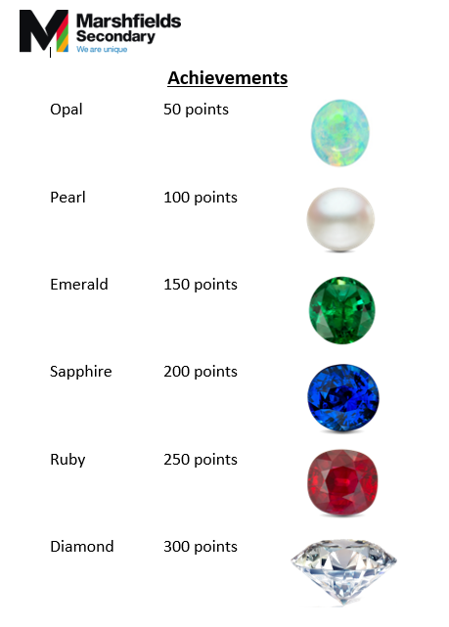

APPENDICES

Appendix 1:

KEY BELIEFS EXPLAINED

We believe that:

Children and young people want to behave well. We believe that our children and young people are happy when they behave well and when that behaviour is recognised and acknowledged by adults and their peers. Children can behave well when their needs are well met in school, at home and in the community.

Behaviour and Communication - how children behave gives us valuable information about how they are feeling.

- Supporting children to effectively communicate is a very important part of supporting children and young people to behave appropriately.
- Children with profound and complex needs will need a personalised approach to behaviour management and consideration must be given to sensory needs, pain thresholds and levels of stimulation and engagement.
- Children and young people can learn to improve their behaviour. Learning new behaviour is a task, just like learning to read or write.
- As adults, we must consider the learning styles and needs of children and young people; we must also have realistic expectations about the rate of progress a child will make when learning to adapt or develop new behaviours.

Mistakes are part of the learning process. We do not make a judgement about it – instead, we support our children and young people to get it right.

All adults can learn strategies to support children and young people to improve their behaviour. Most adults have evolved ways of responding to children’s behaviour based on a combination of personal and professional experiences and training and experiential learning.

At Marshfields we encourage all staff to reflect on what may be the underlying issues that drive or trigger behaviour in children, and to think about ways of responding to difficult behaviour in a non-judgemental and supportive way. All adults must be committed to developing their practice and sharing their skills and experiences. This is a commitment to on-going professional development - our commitment to Coaching and Mentoring, reflective practice and peer support improves performance and professional competence.

Adults can support children and young people by:
The quality of our relationships with each other and them

- Our relationships with each other are supported and developed by our Staff Code of Conduct. They always provide a framework to help us to provide good models of behaviour for our children and young people.

- Each adult is a significant adult for our children and young people. To foster successful, enabling relationships we need to:

  - Actively build trust and rapport – they must be earned: they are not given.

  - We should have high expectations for all children and young people and when we demonstrate our belief in them, it supports them to succeed.

  - We always treat children and young people with dignity and respect e.g., by saying ‘thank you;’ by communicating carefully and clearly in a way that is accessible to them and their current level of need.

  - Adults should listen respectfully to the child or young person and make a judgement about how/when to respond.

    - Invest in your relationships with the children and have fun together.

    - Consider what might be behind the behaviour; why the child or young person is behaving in this way. There will always be a reason: the behaviour is a symptom of something that we need to identify.

    - See things through e.g., consequences in place as a response to behaviours, both desirable and undesirable

    - Keep our word – and if, for some reason, we are unable to honour a commitment to a child or young person, to communicate clearly and honestly about why this has happened.

    - Identify the strengths in the child or young person – identify these with the child and build on it. If a child is not able to do this, advocate for the child within the team or professional group.

    - Apologise if you make a mistake – you are modelling this for the child or young person, and this will support you to build trust and respect.

The quality of our provision:

If we can meet each child at his/her point of need, it is more likely that difficult or dangerous behaviour will decrease or stop. To do this we need to:

  - Accurately assess the child or young person’s needs

  - Plan to meet the child or young person’s range of needs specific to the plans drawn up by their professional group e.g., equipment, staffing, sensory needs.

  - Support the child to develop high levels of resilience and have high expectations for every child.

- Support children and young people to develop high self- esteem, so that they believe that they can succeed.

- Frequent positive reinforcement when things are going well and minimal feedback for low level undesirable behaviours. Focus on what you want the child to do.

- Know what motivates each child or young person.

- Personalized learning to ensure that we meet each child or young person at his/her point of development.

- Where appropriate, include the children and young people in the target-setting and evaluation process for outcomes measurement, using appropriate language and methods (self-assessment)

- Give the child or young person feedback on progress in a supportive way that makes sense to them, focusing particularly on their achievements and what they need to do to make further progress.

- Praise the children and young people for their specific achievements, i.e., descriptive praise and do this often.

- Actively teach the children and young people behaviour for learning

The scaffolding we put in place – by this we mean all the things we do to support our children and young people to manage their own behaviour successfully.

The scaffolding

Boundaries support positive behaviour. They should be:

- Few

- Where developmentally appropriate, agreed with children and young people.

- Communicated in a way that the children and young people can understand, including visual cues, objects of reference, social stories etc.

- Stated in the positive – things we are going do.

- Regularly referred to by all staff with children and young people

- Appropriate to the activity and developmental range

Routines support our children and young people by fixing desired behaviours in their minds. They must be explicitly taught – do not assume they know them. You will need to teach routines for all activities. The more consistency there is over routines, the easier it is for our children and young people. Routines also support behaviour for learning.

OFFENSIVE WEAPONS OFFENSIVE WEAPONS – DEFINITION

An offensive weapon is any implement that is made, adapted, or intended for an offensive purpose and can be used by a person to frighten, intimidate, or cause physical injury to another person.

Principles

This policy is designed to recognise the considerable danger and physical harm that can be inflicted on any member of the school community using an offensive weapon.

Marshfields seeks to:

- Make it clear to all in the school community that the possession of offensive weapons whether inside or outside school is illegal.

- Ensure all in the school community understand that offensive weapons must not be brought into school and that their possession at any time cannot be justified.

- Ensure that where an offensive weapon is discovered in school clear procedures are followed to ensure the safe collection and disposal of the weapon.

- This policy should be read in conjunction with the School’s Behaviour Policy

Guidelines Guns

A member of staff should not attempt to decide whether a gun is real or not.

All guns are to be treated as real.

On hearing of an Offensive Weapon in school

If any member of staff hears that an offensive weapon has been brought into school, they should immediately inform the Headteacher or Deputy Headteacher. Under no circumstances should they investigate themselves. The Headteacher or Deputy will contact the police and conduct an immediate investigation.

Every situation involving the discovery or possession of offensive weapons is unique. The following guidelines cover the general categories of incidents involving offensive weapons:

On discovering an Offensive Weapon

1. Offensive Weapon discovered on the school site:

For all offensive weapons other than guns:

The weapon must be taken to the School Reception. Reception will then inform a senior member of staff. The finder must record the discovery in the Offensive Weapons Incident Log (see Annex 1 below) in Reception.

For guns:

Under no circumstances handle the gun, leave it where it lies. Clear all students from the area, and if possible, isolate it, such as locking it in a classroom. Ring Reception and ask for a member of the Marshfields School Senior Leadership Team. The finder must record the discovery in the Offensive Weapons Incident Log in Reception.

2.

- Offensive weapon in the possession of a person who is member of the School Community:

  - For all offensive weapons other than guns:

The person in possession needs to be told calmly to put the weapon down. The member of staff should then remove the weapon to a secure place. A senior member of staff should be sent for immediately.

If there is a refusal to put the weapon down, a senior member of staff should be sent for directly. Under no circumstances should a member of staff attempt to remove the weapon from the person.

  - For guns

If a person enters your class with, or produces a gun in the class, the person in possession needs to be told calmly to put the weapon down. Once this has happened all students should be escorted to a place of safety away from the gun. If possible, lock the gun in the room. Report the incident to Reception immediately via the nearest telephone or send a student immediately to Reception.

If the person refuses, do not argue or attempt to take the gun off them. Note the identity and features of the person in possession of the gun. Ensure any students in the vicinity are moved far away and report the incident to Reception via the nearest telephone or send a student immediately to Reception.

Senior staff should ensure the police are called immediately and then go to support the member of staff reporting the incident. The Headteacher should be informed immediately. In the absence of the Headteacher the Deputy Headteacher should be informed.

It is the responsibility of the member of staff initially reporting the incident to record the incident in the Offensive Weapons Incident Log in Reception.

- Offensive weapon in the possession of a person who is not a member of the school community:

  - If an offensive weapon is seen on the school site in the possession of someone who is not a member of the school community note the location, distinguishing features, and direction the person is moving and inform Reception or a senior manager immediately. The police will be informed.

Under no circumstances approach or make oral contact with the person and wherever move students away from the immediate area.

3. Students in conflict producing offensive weapons

Under no circumstances attempt to remove the offensive weapon from the student.

Try to calm the situation from a safe distance, if possible, without compromising personal safety and ask the student to put the weapon on the ground. If they refuse, move to a place of safety immediately.

If a physical conflict has started and offensive weapons are in the possession of one or more of the students do not intervene.

For all incidents send a message immediately to Reception to summon a member of SLT. Try to move other students away from the situation.

All incidents involving offensive weapons must be recorded in the Offensive Weapons Incident Log (Annex 1) that is held in Reception.

4. School response to incidents involving Offensive Weapons

- All serious incidents involving offensive weapons will be reported to the police immediately, including any persons in possession of weapons identified by the Site Management staff when the school is not in session. The police will collect and dispose of offensive weapons.

- Each incident will be fully investigated by a member of SLT and reported to the Headteacher.

- Staff will be informed of all serious incidents concerning offensive weapons on the school site as soon as possible.
- For all serious incidents concerning offensive weapons in Section 2 reference will be made to the

School’s Critical Incident Action Plan. Such incidents will be reported to the Governors of the

School.

- The school will treat each incident separately and respond with an appropriate course of action and appropriate disciplinary measures. Depending on the nature and severity of the incident temporary or permanent exclusion may result. As in all other incidents where exclusion is considered, this will be the decision of the Headteacher.

- Under no circumstances should a member of staff speak to anyone related to the media following a serious incident concerning an offensive weapon. Refer all enquiries for information from the media to the Headteacher.

5. Raising Awareness of the Dangers and Legal Aspects of Offensive Weapons

- All students will be spoken to annually about the dangers of offensive weapons by the staff of the school and/or the police. This guidance to include the Law and the possession of offensive weapons.

- Staff will be informed of any further guidance that becomes available.

Marshfields School

Annex 1 Offensive Weapons Incident Log Important

Please record all details legibly and carefully as this document may be produced in a Court of Law.

Reporting Staff:

Date of the Incident: | Time of the Incident:
Location of the Incident:
Name of Persons Involved:
Senior member of staff who investigated the incident:
Type of Offensive Weapon: | Police Involvement: Yes / No
Description of the incident: (include those involved and the sequence of events)

Continue the reverse if necessary.

Signed: Date:

Annex 2 – Use of De-escalation Script:

USE of the SCRIPT

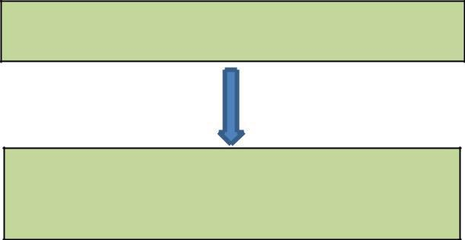
Inappropriate Behaviour or Language

Remind students of expectations and

give time as needed.
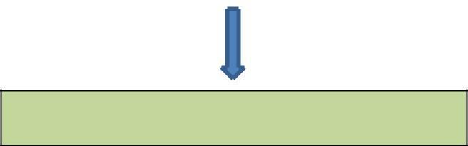

Continued Inappropriate Behaviour or Language

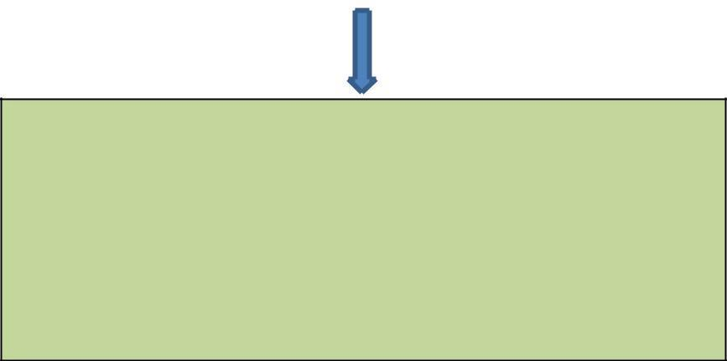

De-Escalation Script

 

•

•

•

•

•

Learners Name 

I can see something has happened 
I am here to help 

Talk and I will listen 

Come with me and ……. 

Positive Choice Negative Choice
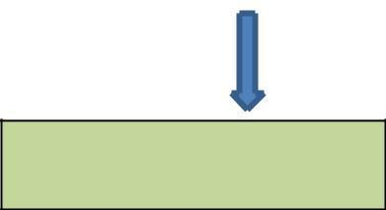

Allow time to calm.

Continue with learning or

activity

De-brief (explore with STA or DHT)

Return to learning or activity if appropriate.

Differentiated Space (STA or DHT)

Educational consequence applied.

Annex 3 – Reflection Flow Chart:
After an incident with
Reflection Sheet Flow Chart
Student

Isolate the conversation.

Explore student’s point of

view about incident

Summarise discussion to

ensure you have the story

correct.

Connect Feelings with Behaviours

Alternative behaviours

discussed

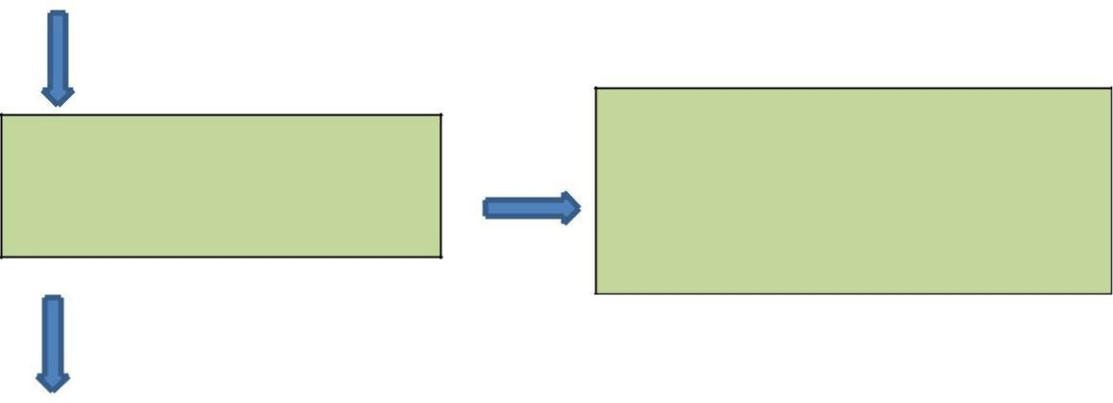

Educational consequence
Reflect, Repair and Restore
(Complete missed work/ letter of apology if appropriate)

Return to learning activity | j

Annex 4 – Fixed Term Suspension Process

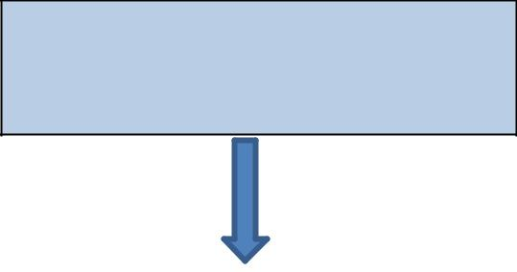

STA/AHT informed of incident if not

already involved.

If incident requires student to leave
site immediately AHT
to take FTS recommendation to HT/DHT

AHT to complete holding phone call to parents to inform them of incident.

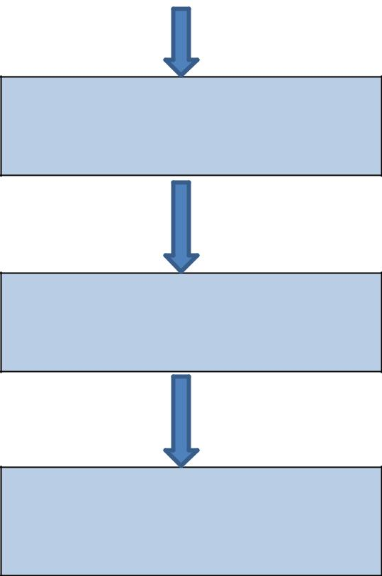

STA investigates (witness statements

taken)

STA to pass completed investigation to AHT.

AHT to decide on recommendation and
take recommendation to HT/DHT

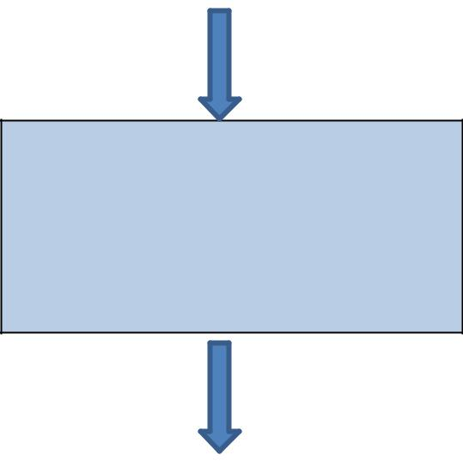

AHT to phone parents to inform them of decision to suspend and arrange readmission meeting. Information passed to HT PA for letter to be produced.

Readmission meeting held with AHT and
Pastoral and targets for readmission set.

Annex 5 – Behaviour Descriptors

Difficult Behaviour

- Using inappropriate language
- Inappropriately dressed.
- Refusing to hand in prohibited items
- Name calling
- Putting yourself in danger
- Refusal to engage in the lesson.
- Smoking within school boundaries
- Leaving class without permission
- Verbal Bullying
- Disruption to the learning of others
- Deliberately lying/avoiding the truth
- Swearing directly to cause offense.
- Persistent refusal to follow Instructions.

Dangerous Behaviour

- Fighting
- Physical with staff (personal space, pushing) Destruction of school property.
- Activating Fire alarm or Extinguisher
- Endangering a fellow pupil/Staff member
- Truancy (possible safeguarding issue)
- Climbing on the roof or in and out of windows
- Failing to follow Health & Safety guidelines.
- Possession of an offensive weapon
- Theft
- Possession of Class A, B, or C drugs; Alcohol or legal High’s abuse
- Persistent refusal to follow DHT or HT instructions.
- Bullying pupils/Staff Physically
- Intimidating behaviour
- Sexual violence or harassment

Dangerous behaviour: Breaches of health and safety rules or behaviour which endangers any of our community will be dealt with on an individual basis as and when they occur. All staff receive Step On training from our team of trainers and are skilled at de-escalation and behaviour management. If the need arises and an individual's risk management plan deems it necessary, the relevant staff will receive Step Up training. As allowed under Section 93 of the Education and Inspections Act 2006 staff may use reasonable force to prevent students from hurting themselves or others, from damaging property, or from causing disorder.

Annex 6: A summary of the Governing Body’s duties to review the Headteacher’s suspension decision.
Will the suspension result in missing a public exam?

The Governing Body is not required to consider the suspension and does not have the power to decide to reinstate a student.
Will the suspension take the students total days of suspension above 5 for the term?
The Governing Body may delegate its functions to consider suspension to a designated committee. References to days mean “school days”.
The Governing Body must consider any representations made by parents but does not have the power to decide whether to reinstate the student.
No
No
Yes
Will the suspension take the students total days of suspension above 15 for a term?
No
Is the exclusion permanent?
No
Have the students’ parents requested a Governing Body meeting?
Yes
The Governing Body must convene a meeting to consider reinstatement within 50 days of receiving notice of the suspension.
The Governing Body must convene a meeting to consider reinstatement within 15 days of receiving notice of the suspension.
The Governing Body must convene a meeting to consider reinstatement within 15 days of receiving notice of the suspension. However, the Governing Body must take reasonable steps to meet before the date of the examination. If this is not practical, the chair of Governors may consider students’ reinstatement alone.
Yes
No
Yes
Yes

