Evidence for Learning – Family App
How to Guide
The Evidence for Learning (EFL) Family App is available via the App Store (Apple devices) and Play Store (Android devices).

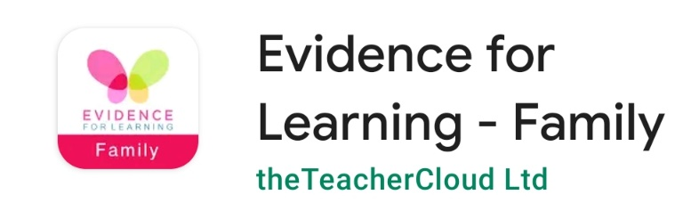
- Go to your app store and search for Evidence for Learning Family, look for the app pictured below.

- Once the app is downloaded, you will be able to sign in via the screen pictured below. You would have been sent the Domain and Username via email. The domain is marshfieldsschool (this is case sensitive) and your username will be your email address. You will not have to sign in again unless you change your details or need to reset your password.
Sign in screen

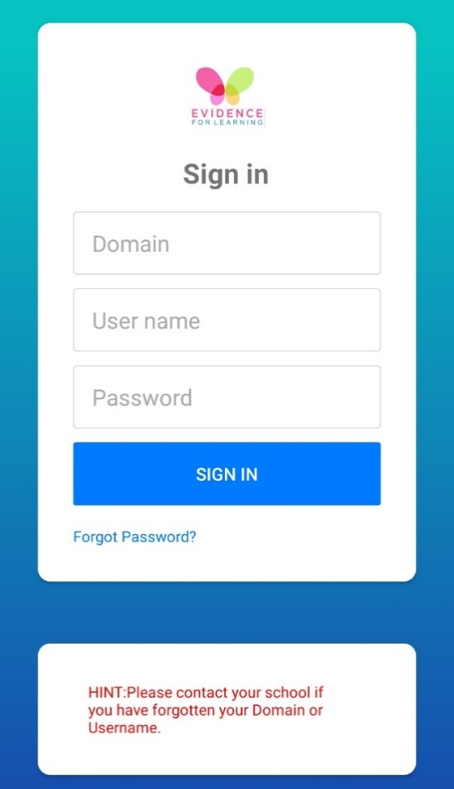

- Once you have signed in, you will see the home screen pictured below.

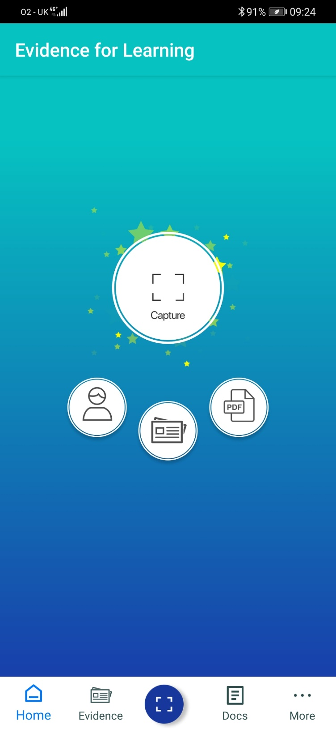
Capture button – You can use this button to quickly add any evidence you would like to share with us.
Evidence button – You can use this button to quickly view any evidence you have uploaded, or evidence school have shared with you.
More button – You can use this button to access your profile settings.

- Capturing Evidence
Click the + button in the empty box, you will be given two options, Take a Photo/Video or Photo/Video Library. Select the option which you require and then select your photo or video.
Click the + button next to learners and select your child, if you have multiple children at Marshfields and the Evidence includes both children, you can select multiple Learners.

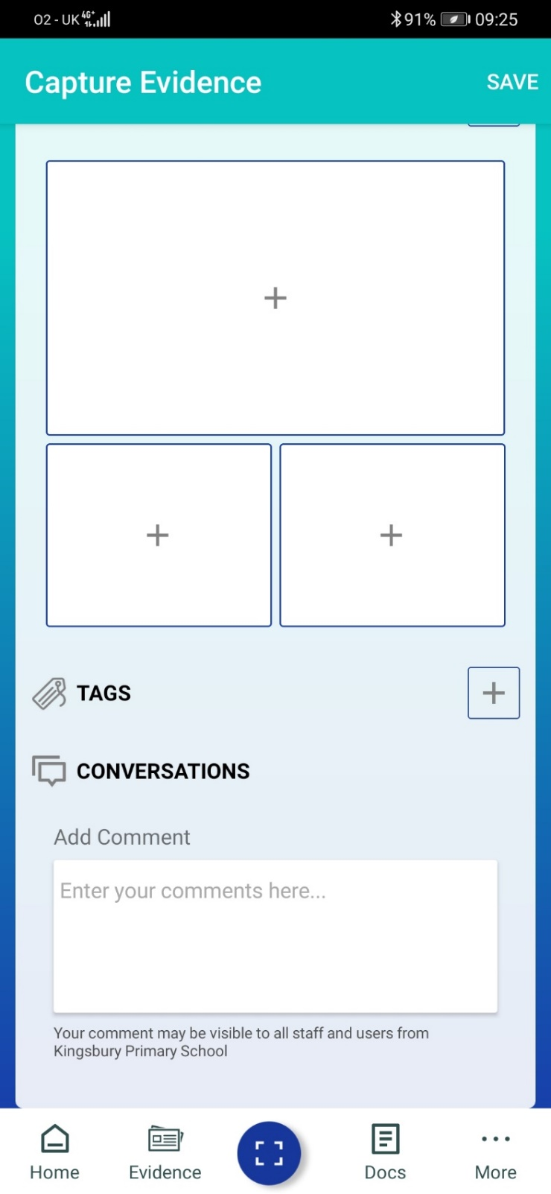
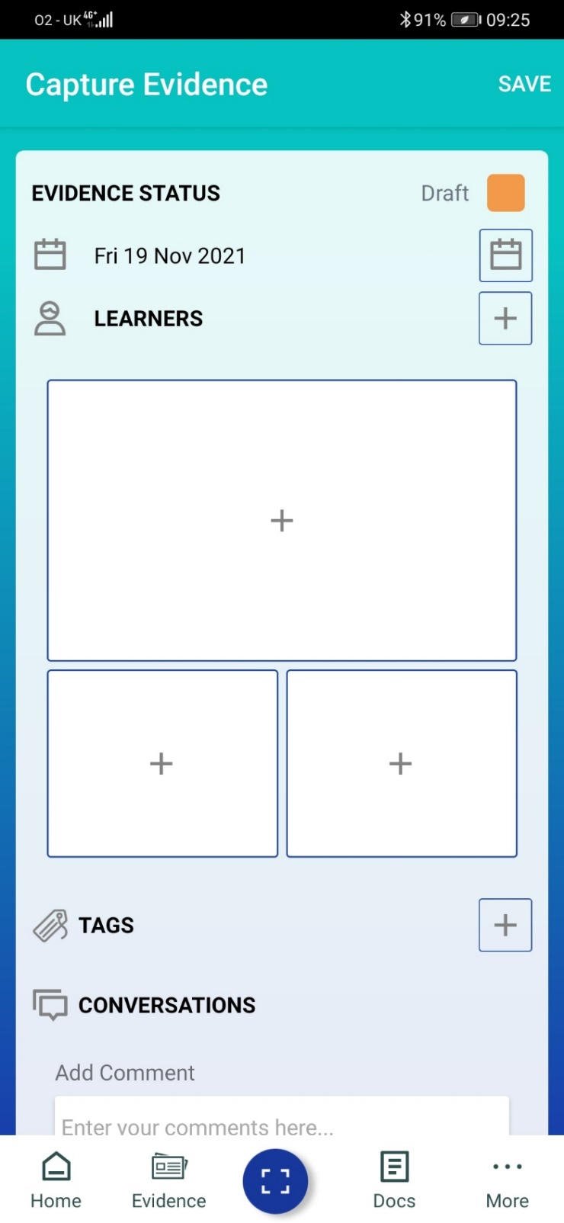
In the conversations section, you can add a comment about the evidence you are uploading.

Once you have selected the learner, uploaded photos/videos and added any comments; you need to change the evidence status to Published and then click Save.
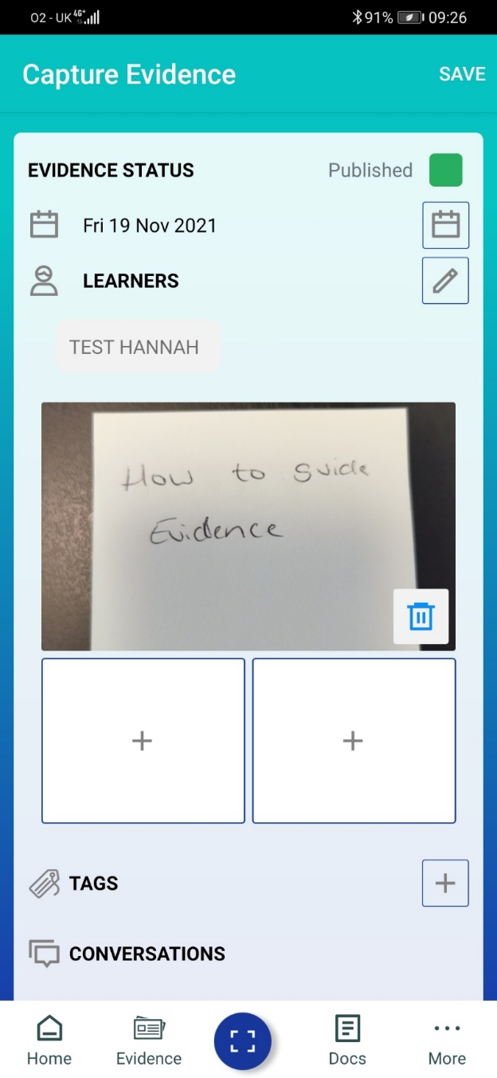

This will save the Evidence, and you will be able to view it via the Evidence tab.

- Viewing Evidence – You have two options to view evidence, the Tile view and the Journal View. You can click into the evidence to see the photos/videos and the comments. You can even leave your own comment if you’d like!


