Packed Lunch Policy

Overall aim of the policy

To ensure that all packed lunches brought from home and consumed in school (or on school trips) provide students with healthy and nutritious food that is of similar quality to food served in schools, which is required to meet national standards.

Where, when and to whom the policy applies:
The policy applies to all students and parents providing packed lunches to be eaten within school or on school trips during normal school hours.

At Marshfields School, we understand that our students benefit from eating a balanced and nutritious diet. Among other benefits, a good diet helps to:

- Keep skin, teeth, and eyes healthy
- Support muscles
- Helps achieve and maintain a healthy weight
- Strengthens bones
- Encourages brain development
- Supports healthy growth
- Boosts immunity
- Helps with the digestive system function

In 2015 the School Food Standards for school lunches was published ¹ to ensure that all children who eat a school dinner benefit from eating quality food during the school day. The standards apply to all food and drink supplied by the school to students, staff and visitors from the start of the school day to 6pm.

Food and drink in packed lunches at Tattershall Primary School:
- We will provide free, fresh drinking water for children to refill their water bottles.
- We will work with parents to encourage packed lunches to meet the standards listed below.
- As fridge space is not available, students are advised to bring packed lunches in insulated bags or in lunch boxes with freezer blocks where possible.
- Packed lunches are stored in cabinets in cloakrooms on arrival at school, so food is kept until lunchtime
- As far as possible students eating packed lunches and students eating school lunches from each class will sit together

Packed lunches should include:
- at least one portion of fruit and one portion of vegetables every day.

- meat, fish, eggs, or a non-dairy protein (e.g. lentils, kidney beans, chickpeas, houmous, peanut butter, falafel) every day.
- oily fish, such as salmon, at least once every three weeks.

- a starchy food such as any type of bread (white or wholegrain rolls, pitta bread or wraps), pasta, rice, couscous, noodles, potatoes or another cereal every day.
- Dairy food such as milk, cheese, yoghurt, fromage frais or custard every day.
- a drink of water, fruit juice (maximum portion 150 mls), semi-skimmed, 1% fat or skimmed milk, yoghurt or another milk drink.

Packed lunches can occasionally include:
- Meat products such as sausage rolls, individual pies, corned meat and sausages (no more than once a week)
- Lower sugar cakes and biscuits, but encourage your child to eat these as part of a meal

Appendix 1 & 2 gives guidance on appropriate potential packed lunches which works alongside the School Food Standards and the information above.
The advice is for guidance for parents and Marshfields School actively encourages meals provided in line with it, however we do not allow the following to be brought into school as part of a packed lunch or for other reasons.

Restricted items
- No fizzy drinks
- No solid chocolate (optional: a single chocolate covered biscuit bar will be accepted)
- No sweets
- No food from fast food outlets
- A single bag of crisps or another savoury snack packet is acceptable
- No cakes and sweets to be brought in for birthdays or other celebrations due to allergy restrictions for students.

Allergy Advice
- A list of allergens (what is provided in the lunchbox) should be provided if any foods are not in packets. Parents may find it easier to keep things in packets (such a oat bars etc). This is to ensure children and staff are safe from potential allergens and that they can be identified as quickly as possible to avoid this.
- Thermos flasks must not be used to keep food warm. We have looked into this and have been advised we must not allow thermos flasks to keep food warm within the setting. This is due to the temperature of the food going into the red zone for safe food temperatures.

Assessment, evaluation and reviewing

Packed lunches will be regularly reviewed by staff.

If a member of staff becomes aware that a child has a fizzy drink, solid chocolate, sweets or food from a fast-food outlet in their lunch they will confiscate the food, place it in a bag and return it at the end of the school day with a letter.

If a child regularly brings a packed lunch that does not conform to the policy, then the school will contact the parents to discuss this.

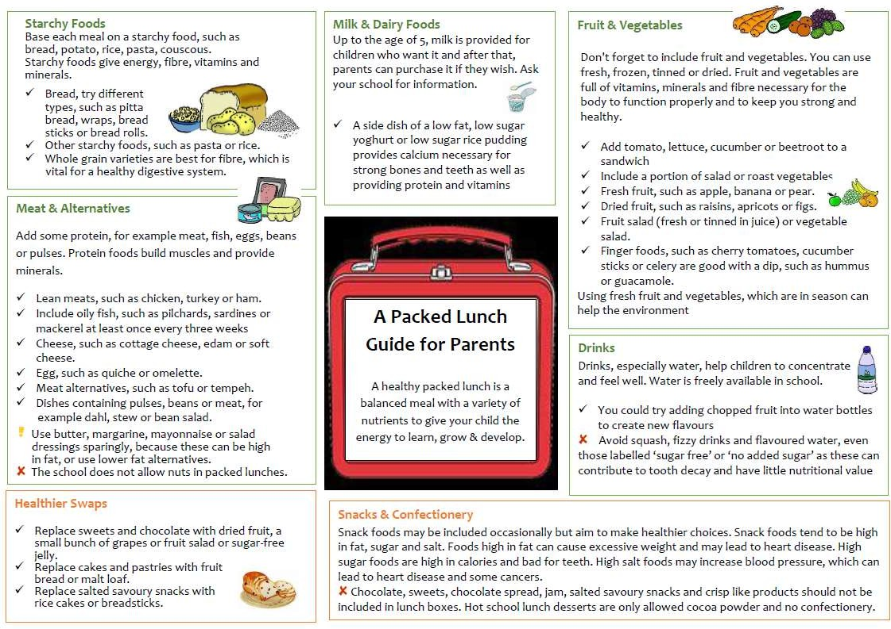
Appendix 1

Appendix 2


