UNIFORM POLICY

Our uniform policy is agreed with parents / carers, governors, and the Student Council. As a School we believe that uniform promotes a sense of pride and belonging.

All students are to wear uniform throughout the day from when they leave home to when they return. Students will also normally be expected to wear their uniform on any day trips unless indicated otherwise by the Headteacher.

Uniform is not a fashion item. It is designed to be both smart and comfortable. This uniform was designed in consultation, to support students SEND needs and ensure it is safe, comfortable, and accessible to all.

The overall impression should be that of a well-groomed individual who takes pride in their appearance.

In the case of extreme weather, the Headteacher has discretion to relax the uniform policy. This will be communicated to students as they arrive at the school. Students should assume that, unless directed otherwise, they should wear their usual uniform each day.

Marshfields School uniform is stocked locally by:

Total Clothing, No 9 Botolph Trading Estate, Oundle Road, Peterborough. PE2 9QP
https://www.totalclothingshop.co.uk/marshfields

GENERAL REQUIREMENTS

Accessories and Devices: Smart watches are not allowed in school. All mobile phones, tablets and electronic devices, the schools Mobile phone policy applies.

Hair: Hair should be well groomed and hairstyles should be conventional and of a natural colour. Haircuts may not include, patterns or logos. Students with unnatural coloured hair will be sent home until it has been returned to a natural colour.

Hats and scarves: Hats are allowed in extreme weather conditions, cap or sun hat in summer and a beanie or bobble hat in winter, hats with adjoining scarves are not allowed. Scarves of any type are not allowed due to health and safety. Hats may not be worn at any time in the school building.

Sun cream: In hot weather sun cream should be applied at home before a student comes to school. Students bringing sun cream into school to reapply may bring roll-on suncream only. Spray and open nozzle sun cream is not allowed in school.

Jewellery: Jewellery should be discreet and safe, no large earrings – just one stud pair. No spacers, bar or dangling earrings. No rings, bracelets or chains are not allowed.

Piercing: A nose stud is allowed if it is discreet. No other visible piercings are allowed and will have to be removed.

Make up: No make-up, nail varnish, false nails or lashes to be worn by students in Key Stage 2 and Key Stage 3. Key Stage 4 students are allowed natural, subtle make-up and clear nail varnish applied to natural nails. Students in make-up deemed by staff to be excessive, will be told to remove it.

Coats: Should be practical for used in school in all weathers. Marshfields School recommends students wear coats with detachable hoods, poppers, Velcro or zip release for easy removal in case of accident or emergency.

Personal care: All students require a full change of clothes in school.

Hoodies are not allowed on any occasion.

SCHOOL UNIFORM - Compulsory Items
All Students new to Marshfields from September 2026 must have these branded items. Students on role prior to September 2026 may continue to wear previous black branded school jumper and black PE uniform. There is no alternative fleece option allowed.

FULL GUIDANCE DAILY UNIFORM ON NEXT PAGE
SCHOOL UNIFORM – ALL Students

There are three compulsory items only. All other items can be branded or unbranded, they must follow the policy and no alternative logos, symbols, ticks, stripes or wording etc. are allowed.

All students new to Marshfields from September 2026, the uniform must follow the colour guidelines as shown in the image below.

Students on role prior to September 2026 may wear the black branded school jumper, white polo shirt and black trousers/ jogging bottoms. When these items become outgrown or unkempt, students' uniform must be replaced in line with the new policy as pictured below.

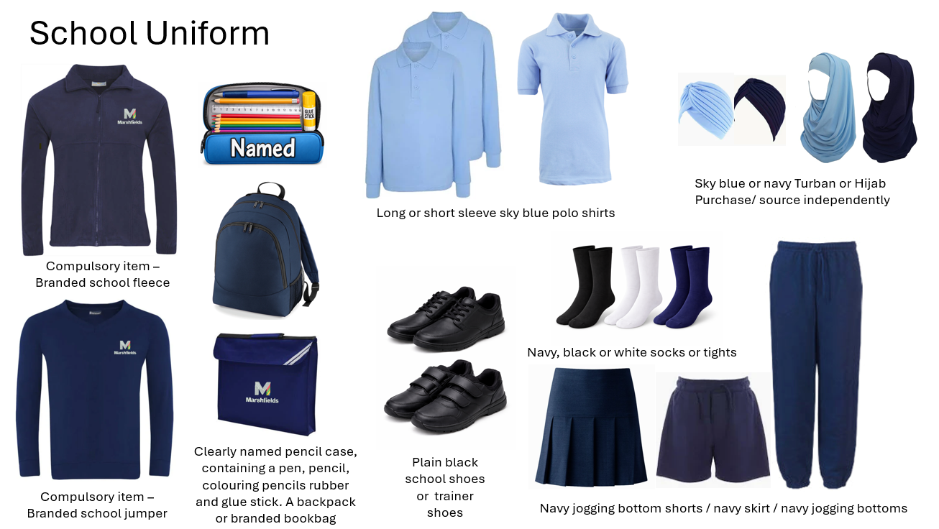

PE UNIFORM – ALL Students
PE uniform includes a compulsory house T -shirt. Parents will receive written confirmation of their child’s house prior to purchasing the correctly colour T-shirt. The school is not responsible for costs ensued for purchases made prior to this confirmation being sent. The house colour will be assigned by school and requests for a specific house will not be accepted.

Uniform outside of the compulsory items that are not purchased from total clothing are allowed however must be plain. No branded logos, words, symbols, patterns or stripes are allowed on any uniform. PE trainers must be plain black and/or white.

FULL GUIDANCE IMAGE OF PE UNIFORM ON NEXT PAGE

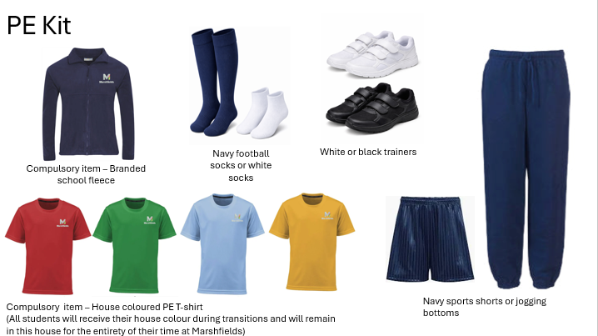

FURTHER GUIDANCE:

All uniform, water bottles, pencil cases, bags and coats must be clearly labelled. School staff are not responsible for your child’s belongings.

If a student is not conforming to the uniform policy:

- He / she may be required to remove the offending item if possible.
- He / she may be given a verbal warning and a date to correct it by.
- A letter and/or phone call home will be made.
- The child and family may be offered support to resolve.
- Parent/carer maybe requested to collect the child and change them into the correct uniform before returning them to school.
- The child may be removed from formal lessons with peers and taught in isolation until the uniform is compliant.

Please note these are not sequential.

Second Hand uniform is available to purchase directly from school. Parents can email the office for sizes and items available.

